**Large Grit Survey Items**

**July 2, 2015**

Survey Outline

Demographics 2

Gender 2

English Speaker 2

Race 2

State/Zip Code 2

YOB 3

Education 4

Employment 4

Income 6

First Job 7

Personal Goals 8

12-item Grit 15

Maximizing and Regret 19

Pluralistic Ignorance 23

Naturals vs. Strivers 24

SES Ladder 33

Counterfactual 35

35

Passion (Vallerand) 36

36

37

38

40

41

Job, Career Calling (Wrzesniewski) 42

42

43

43

44

45

45

Work Calling (Dobrow) 46

Wonderlic 50

Fidelity 64

Scores 66

## Demographics

* Gender
* English Speaker
* Race
* State/Zip Code
* YOB
* Education
* Employment
* Income

### Gender



### English Speaker



### Race

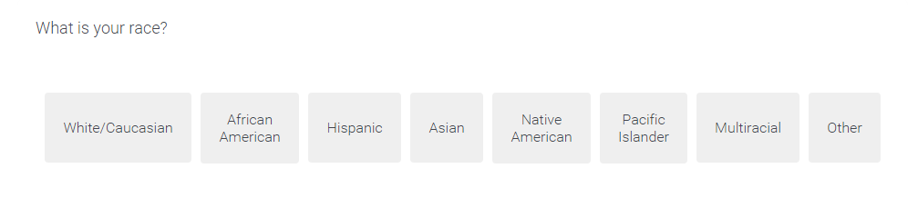

### State/Zip Code



### YOB



### Education



### Employment



### Income

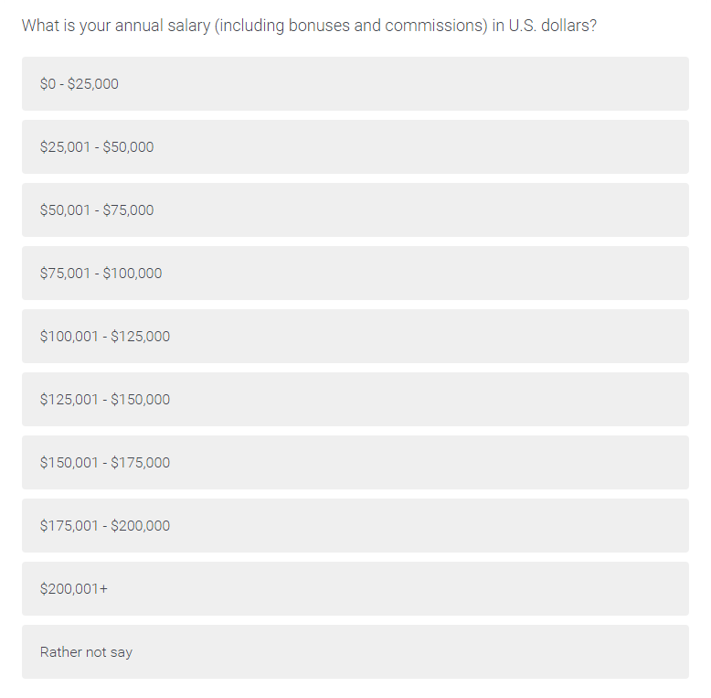

## First Job



## Personal Goals



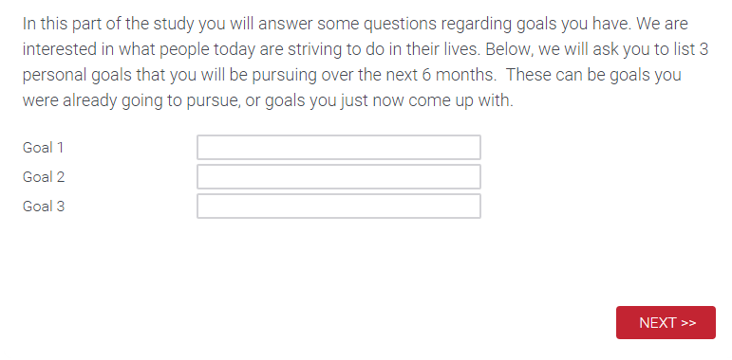



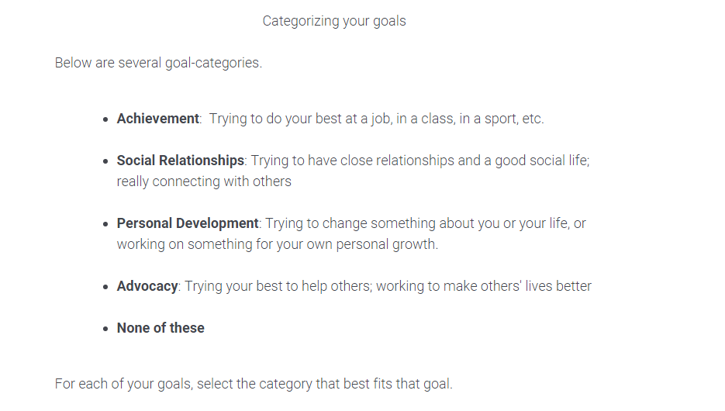

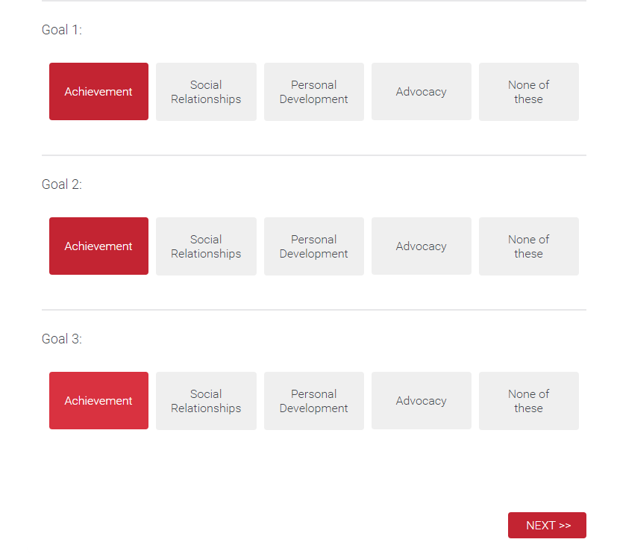



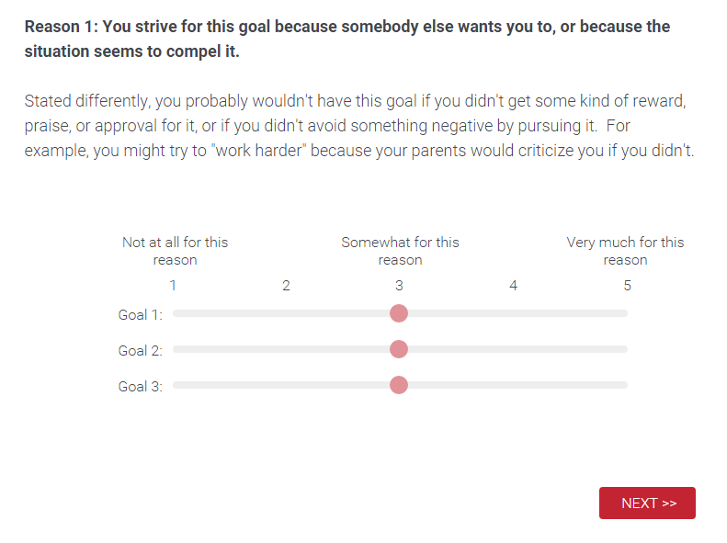

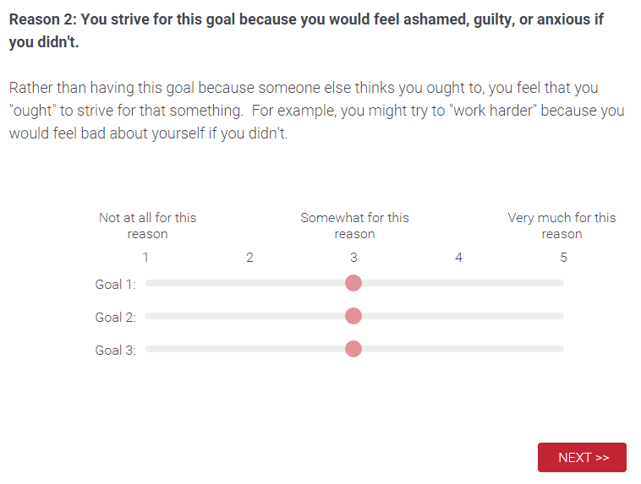

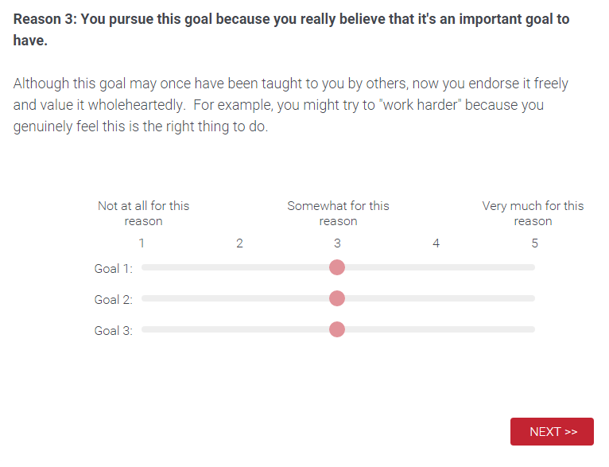

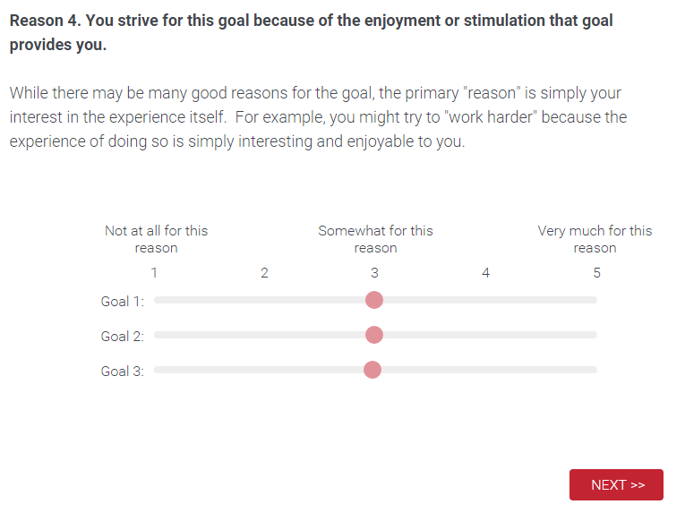

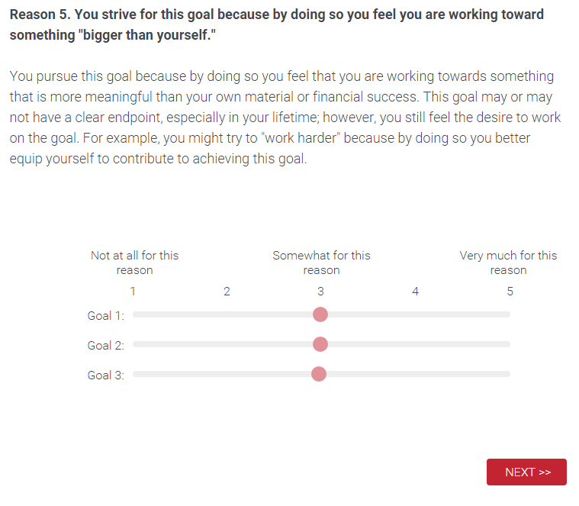

*\*Note: I added reason 5*

## 12-item Grit



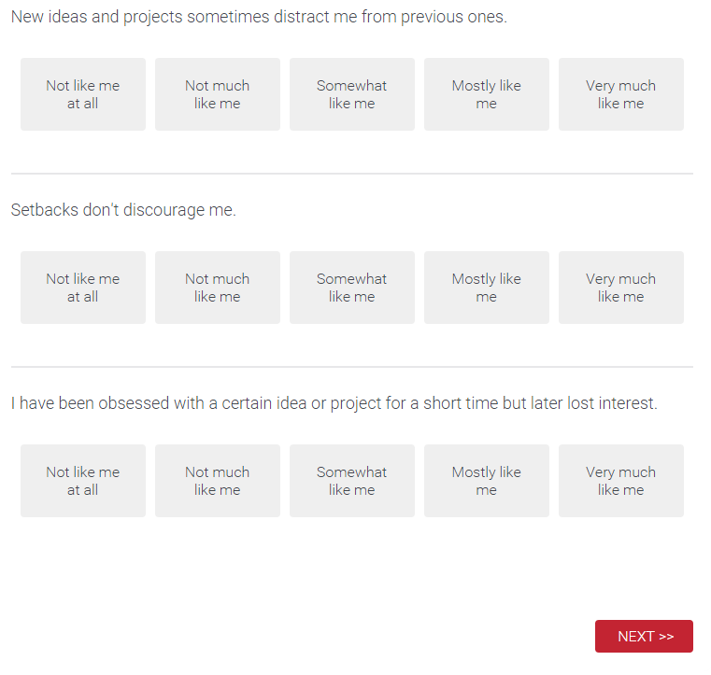



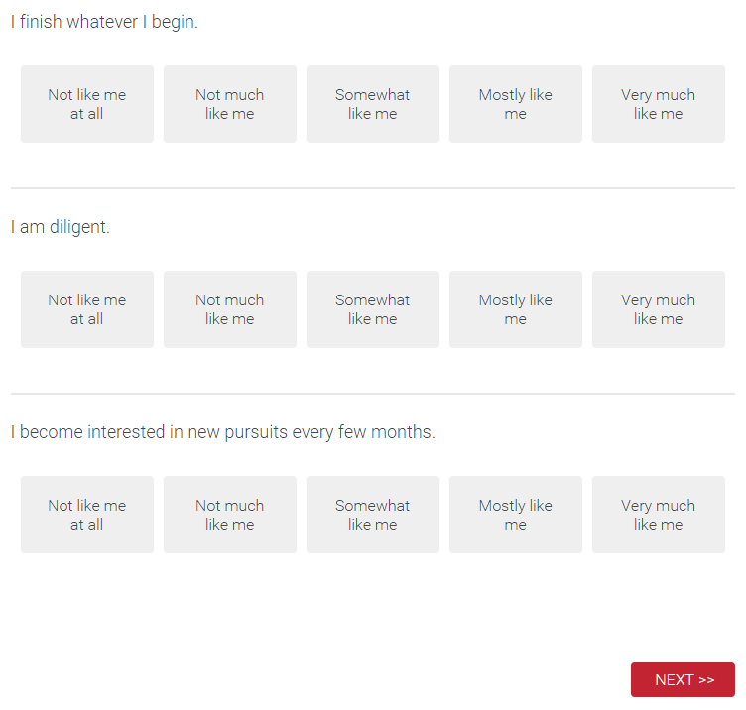

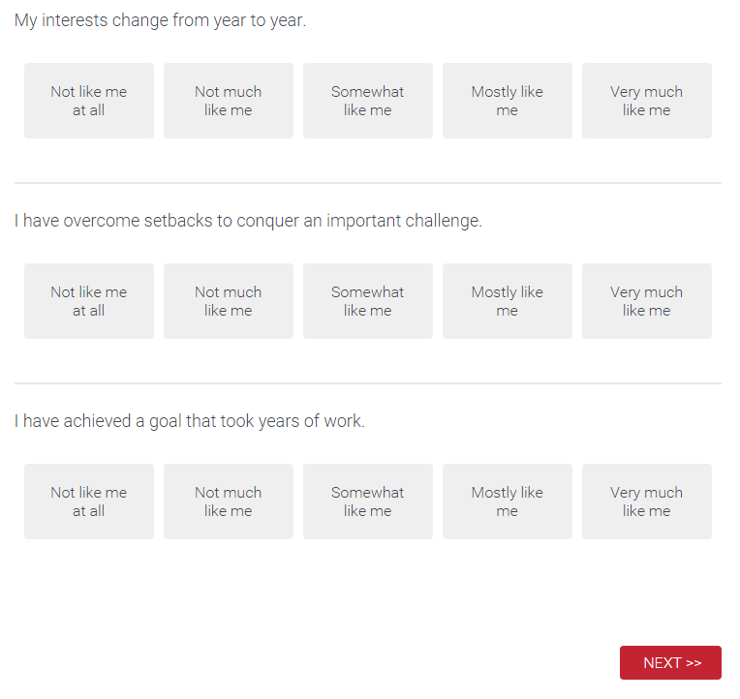

## 

## 

## Maximizing and Regret



Maximizing

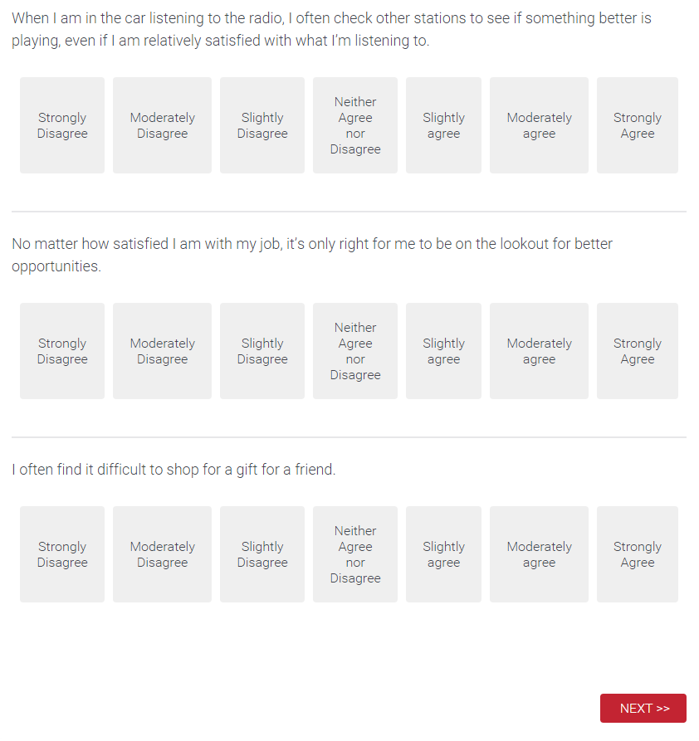

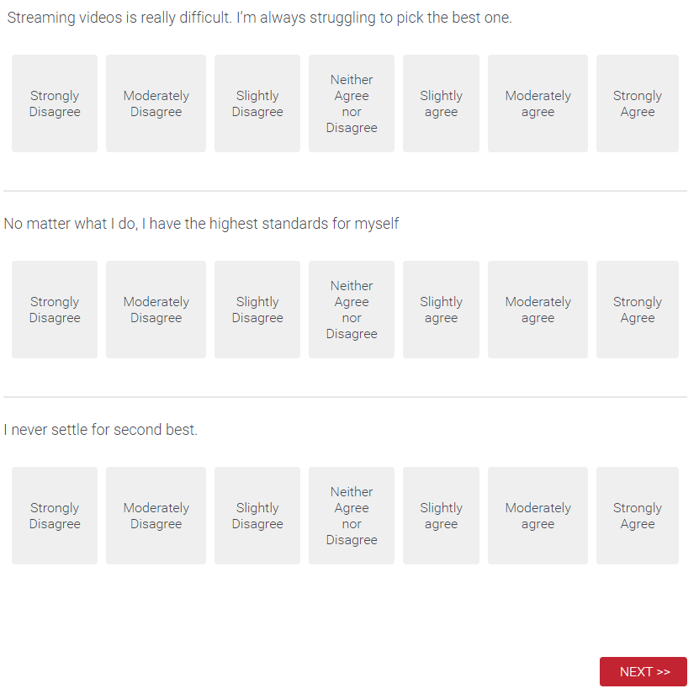

Regret

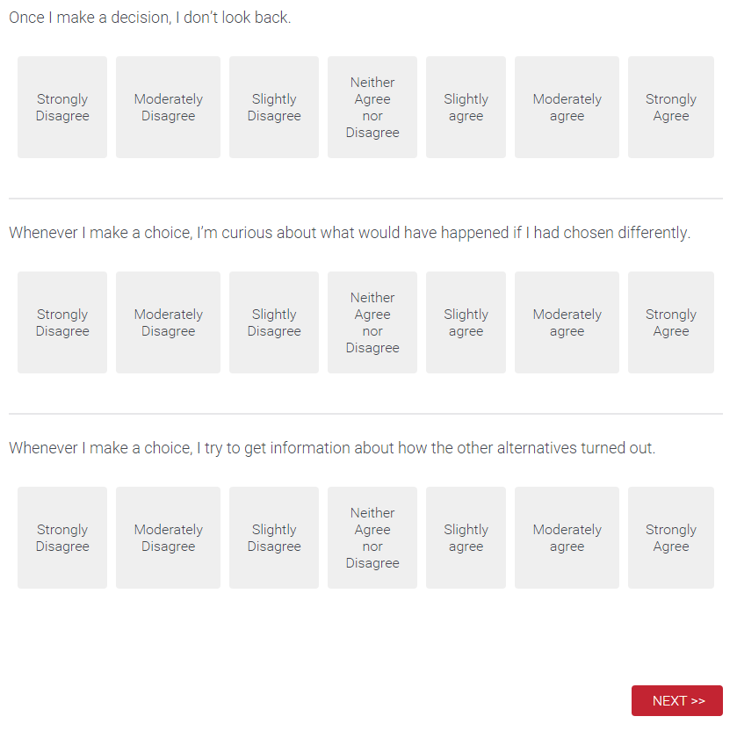

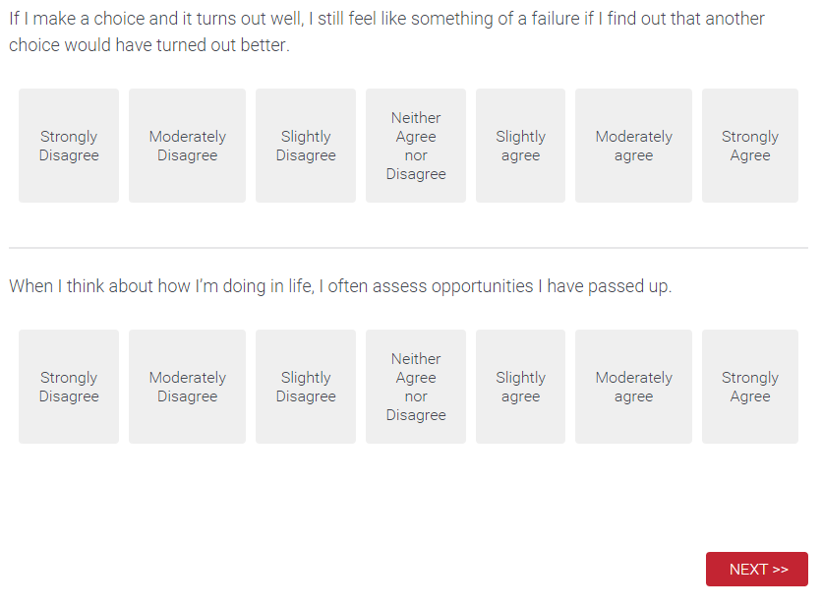

### 

### 

## Pluralistic Ignorance

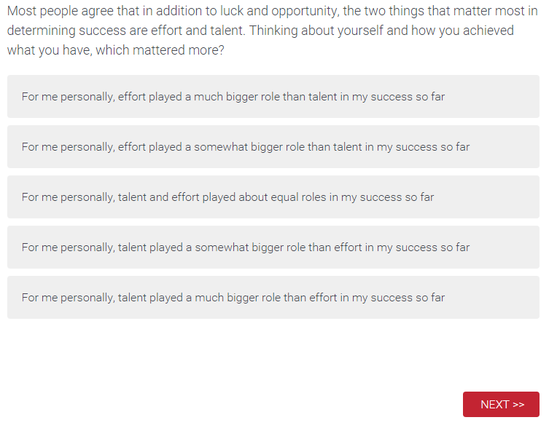

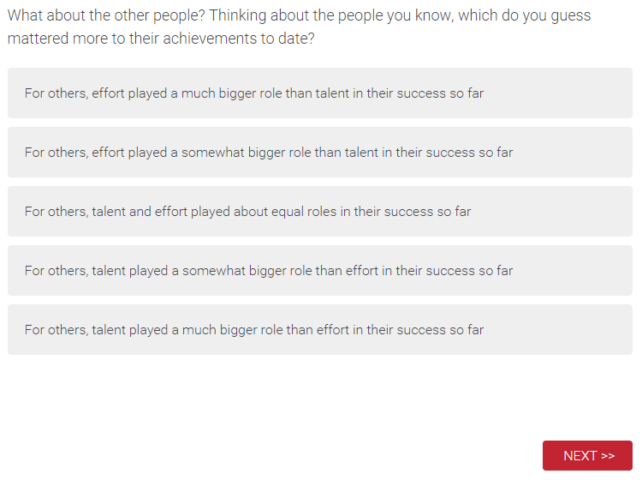

## Naturals vs. Strivers

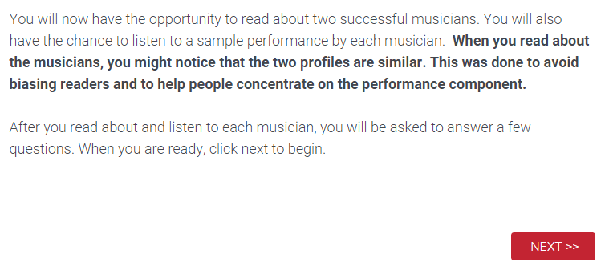



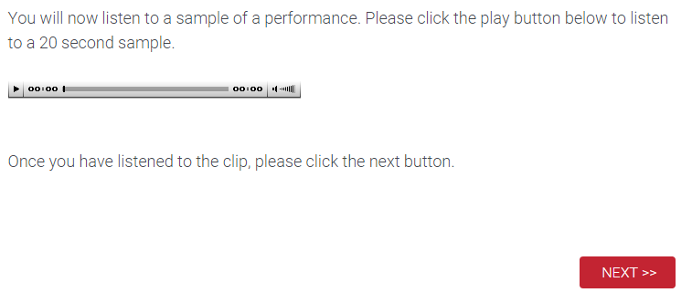



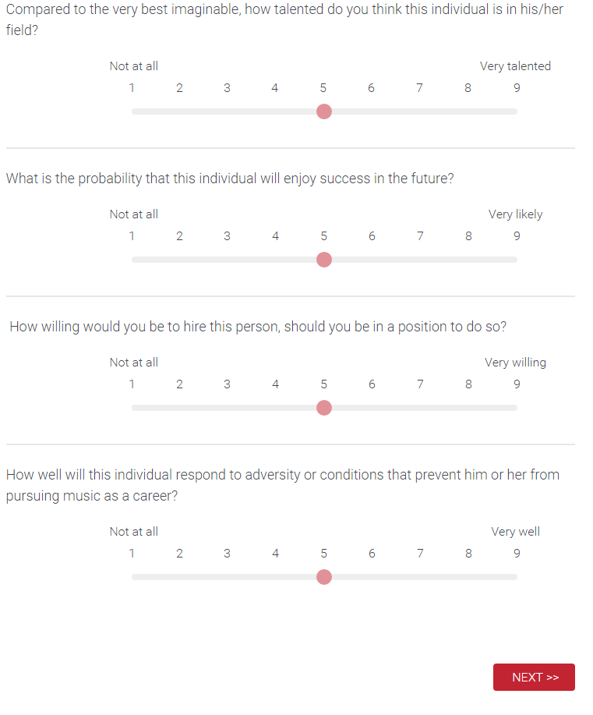

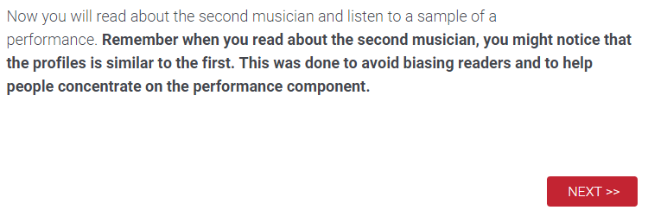



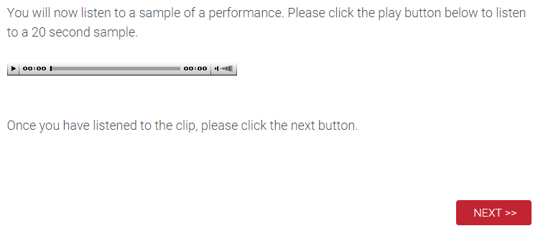



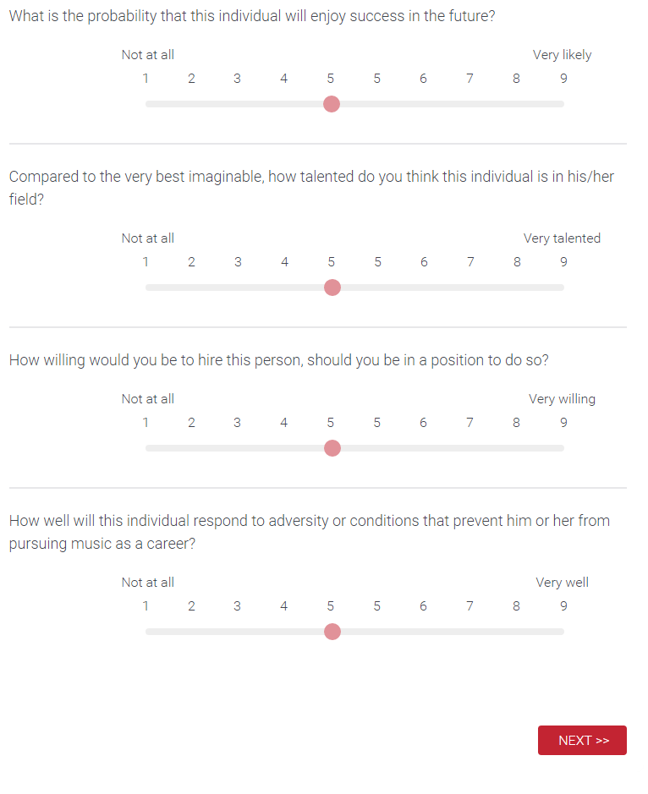

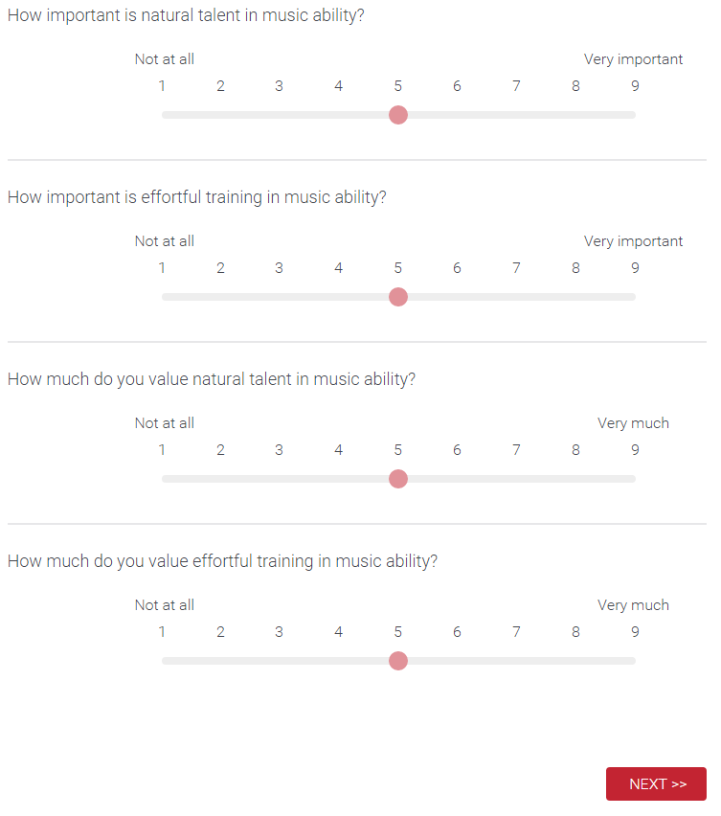

## SES Ladder

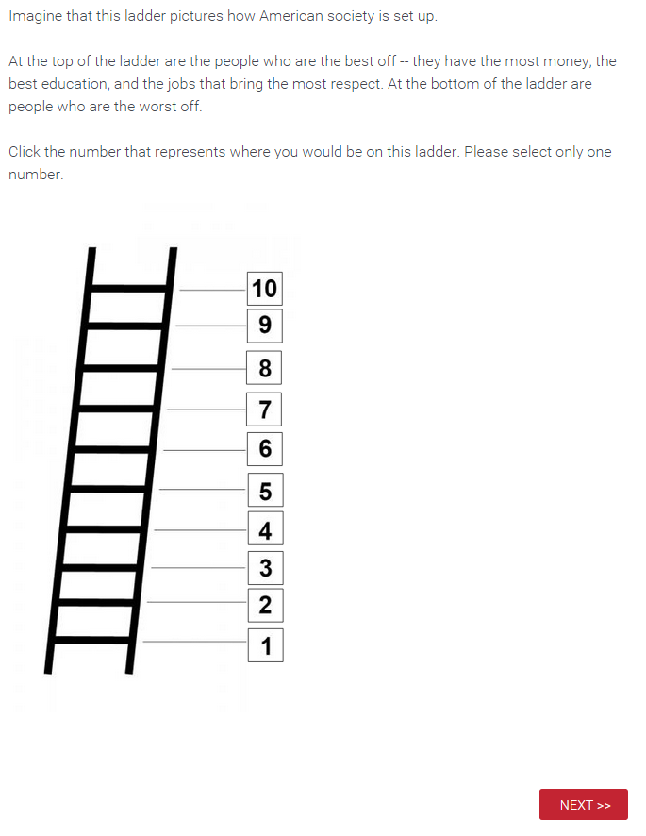

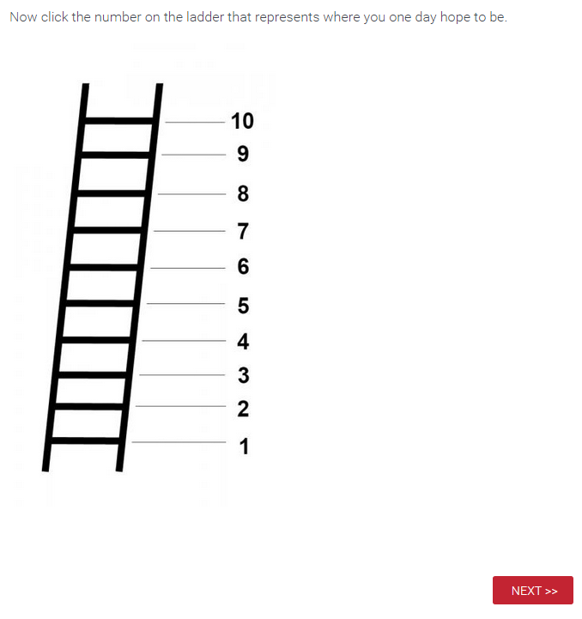

## Counterfactual

## 

## 

## 

## 

## Passion (Vallerand)

## 

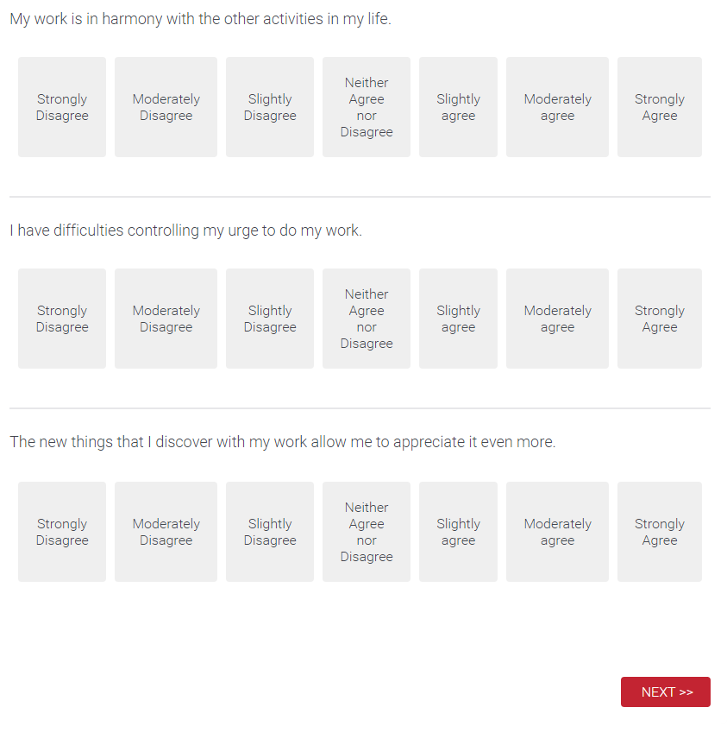

## 

## 

## 

## 

## 

## 

## 

## Job, Career Calling (Wrzesniewski)

## 

## 

## 

## 

## 

## 

## 

## Work Calling (Dobrow)

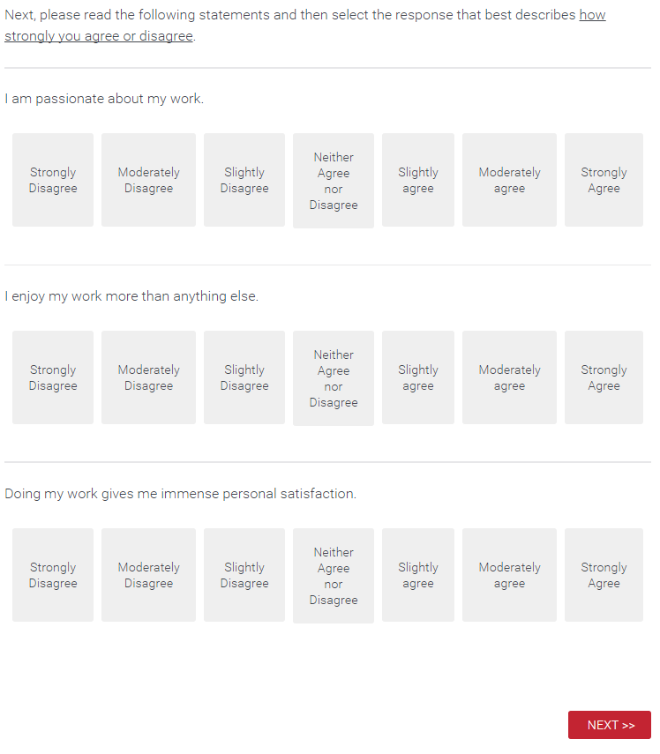

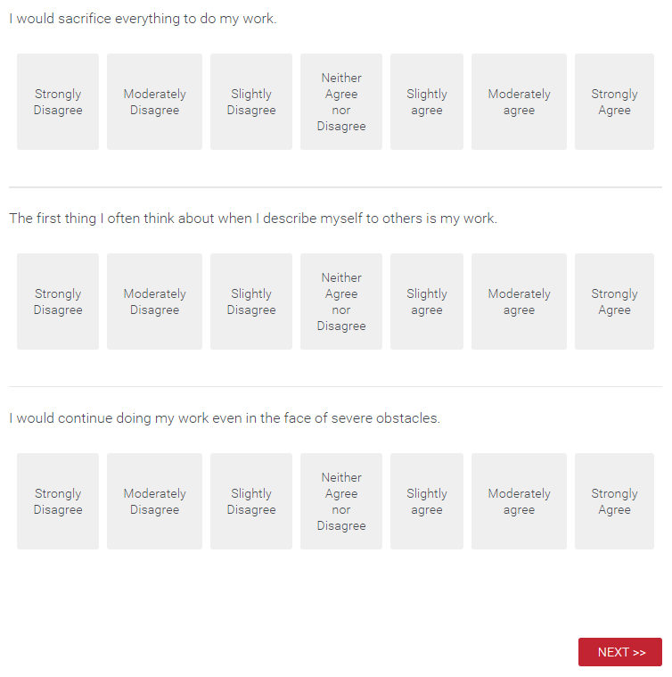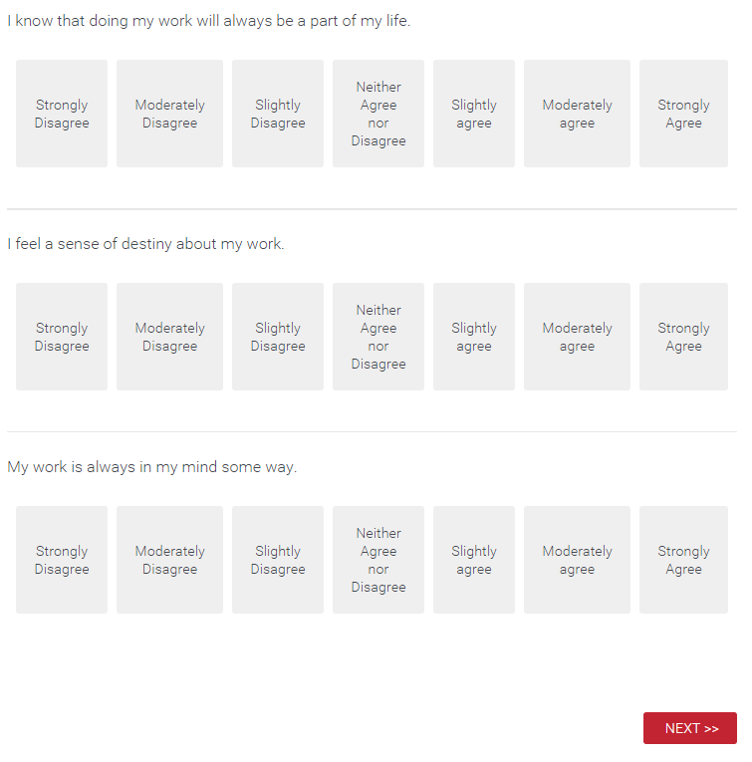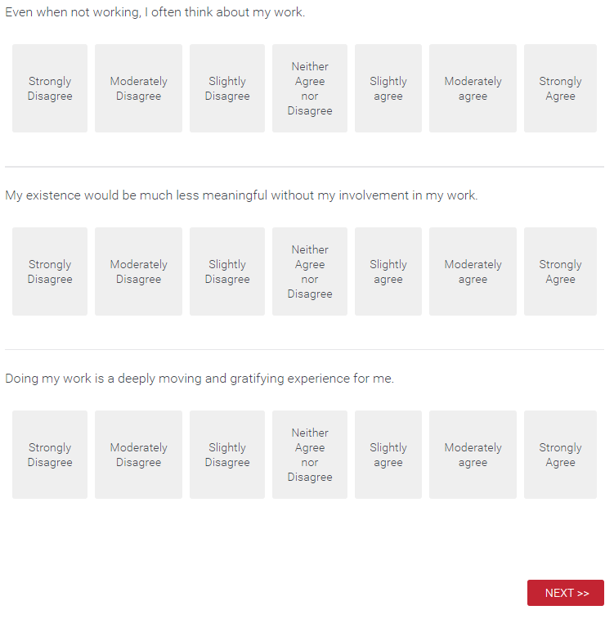

## Wonderlic



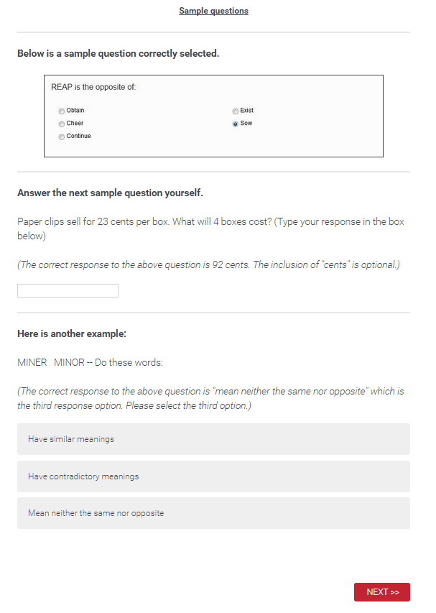





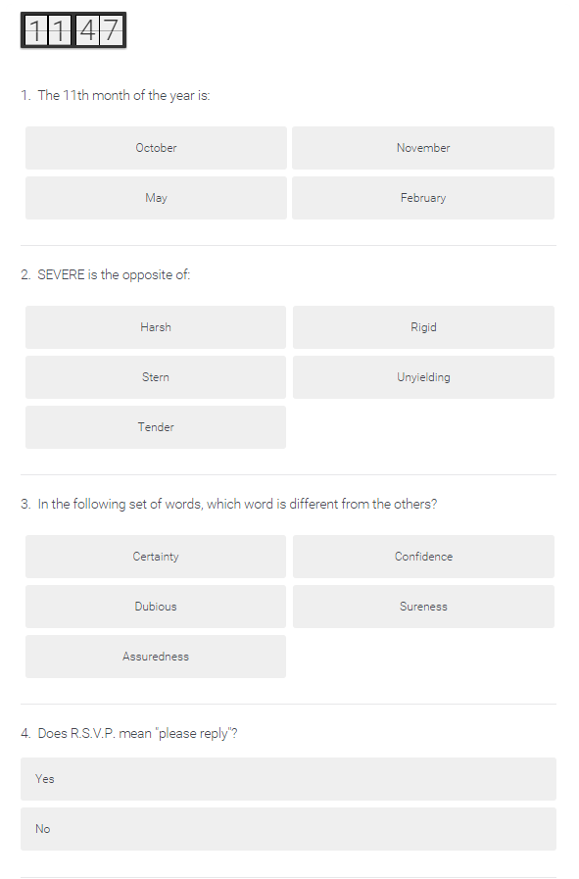

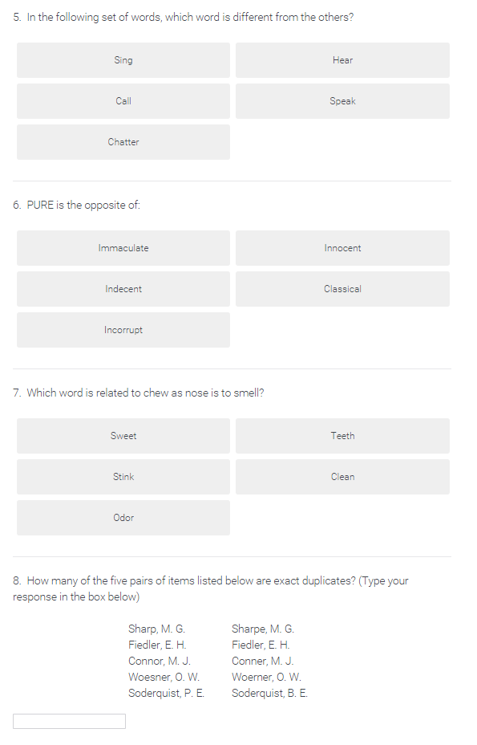

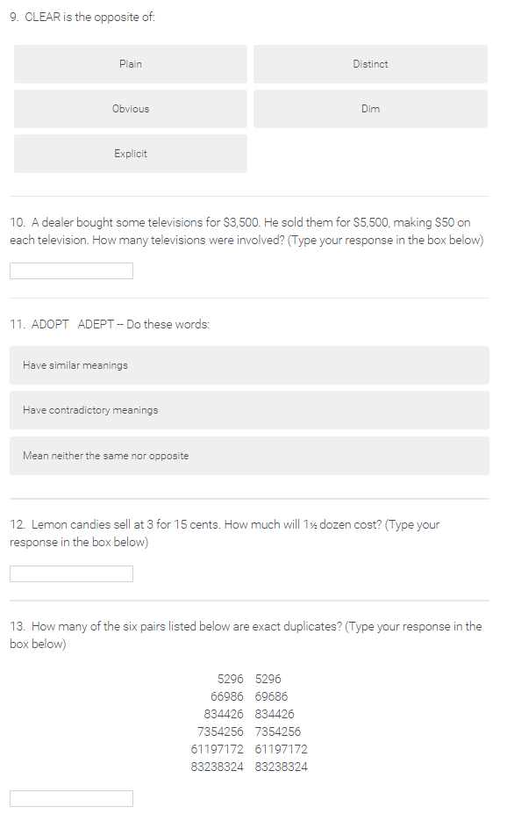

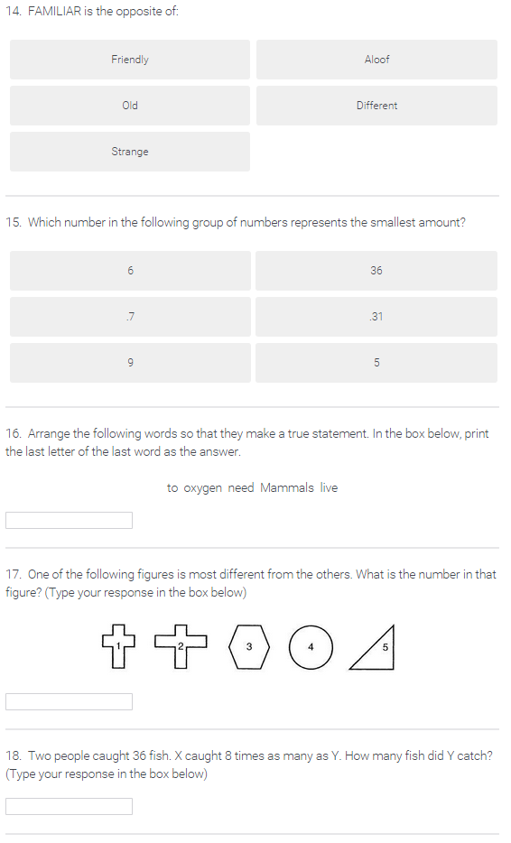

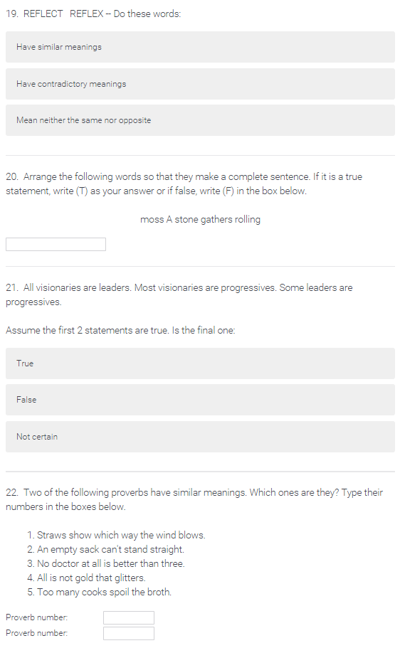

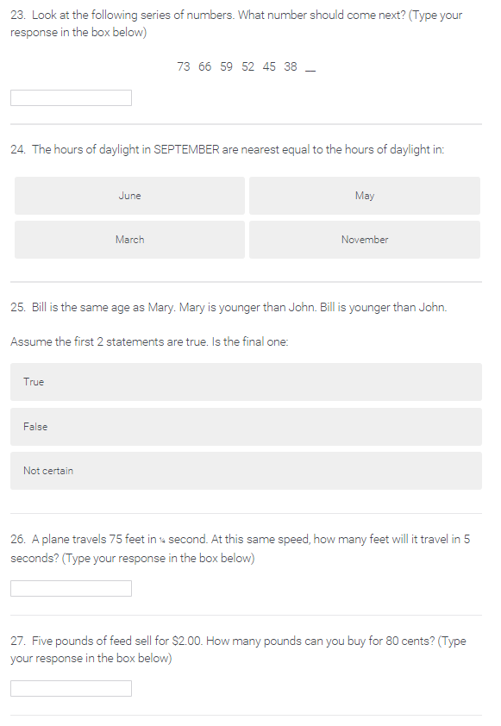

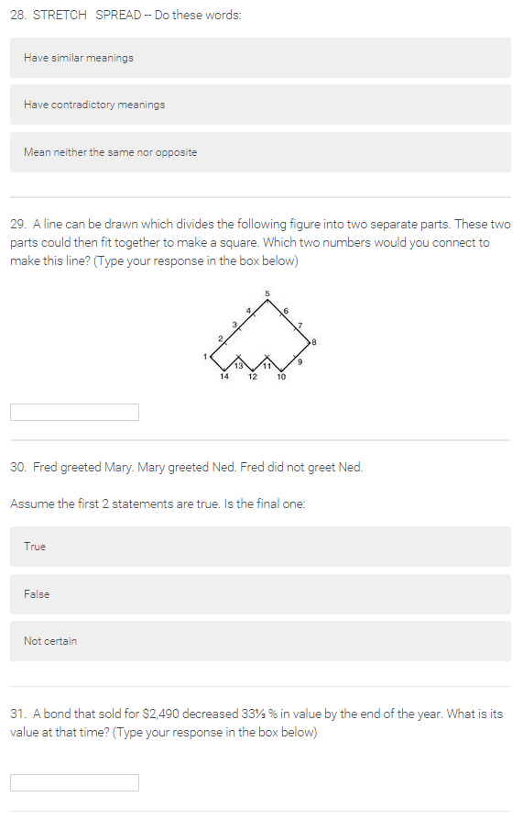

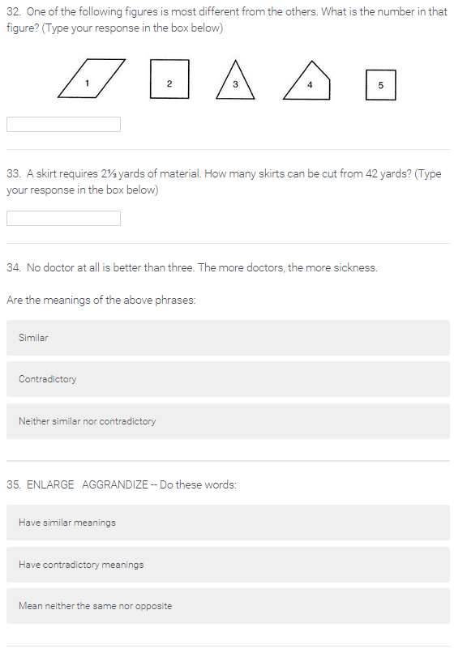

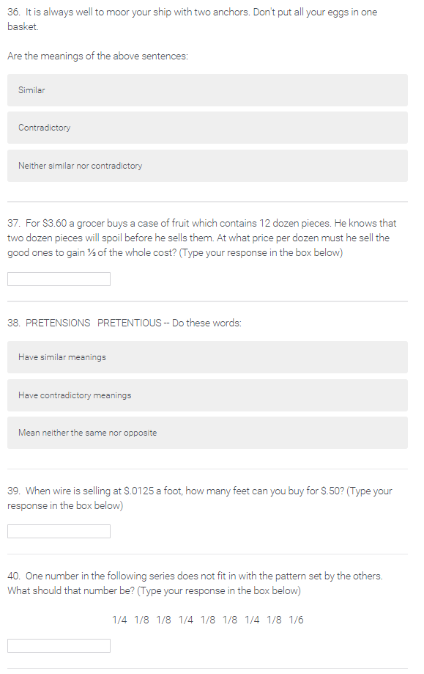

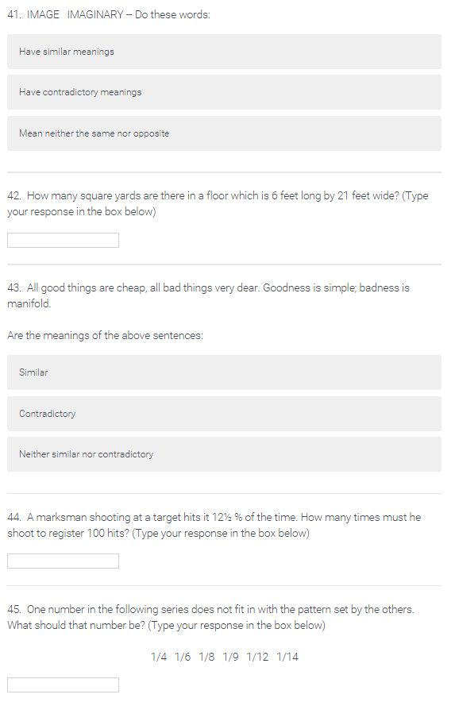

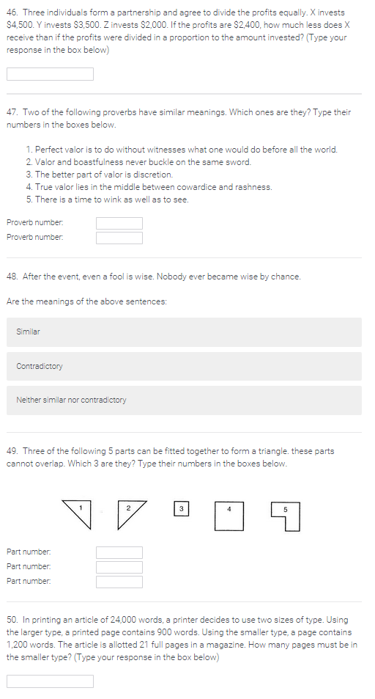

## Fidelity

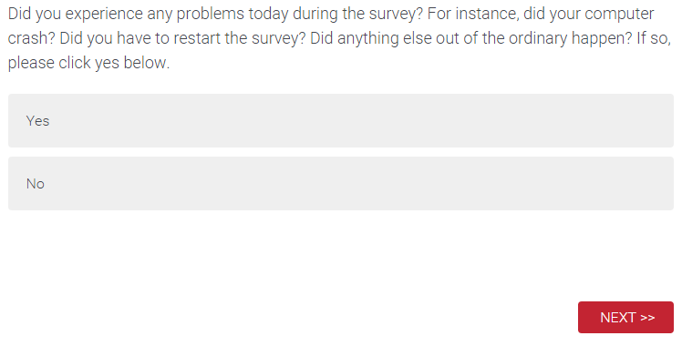



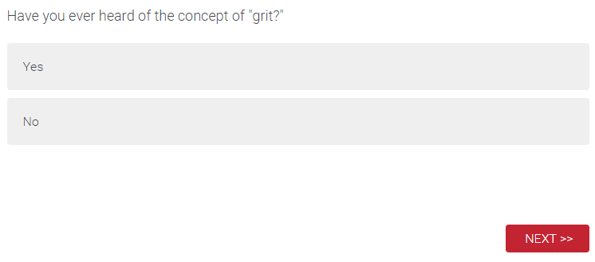



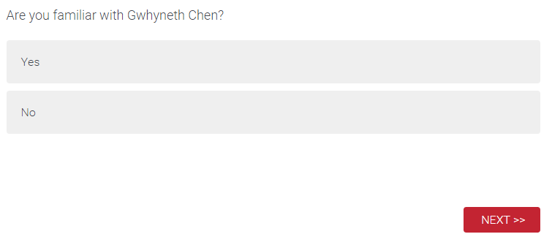

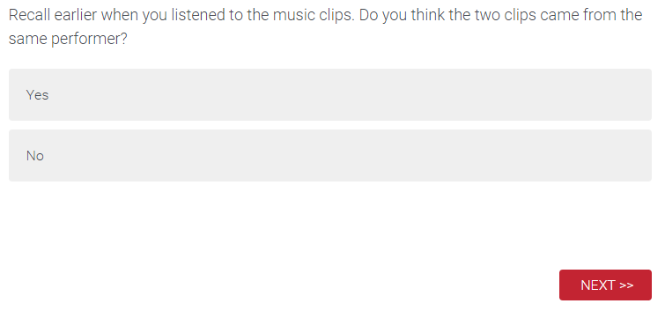

## Scores

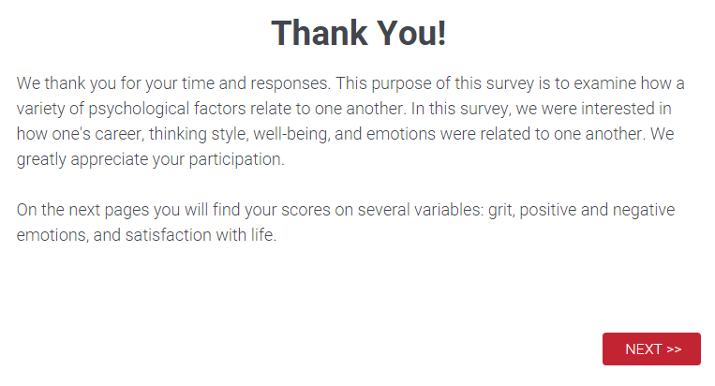



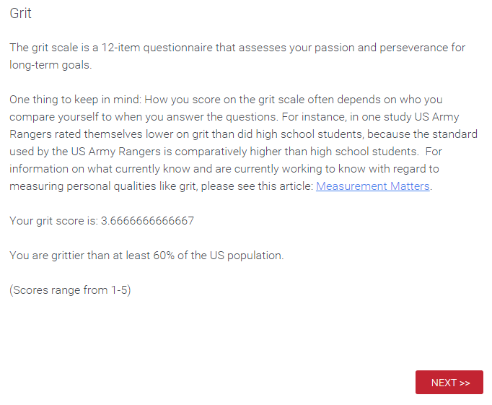



END